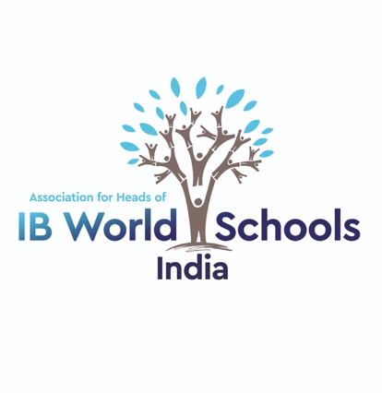
INDIA IB HEADS ASSOCIATION
Western Division Meeting
Date: September 13, 2019
Venue: Mount Litera School International
The meeting started with a brief introduction from everyone present. The following points were discussed
- Legal status: Frank informed everyone that our associations legal status has been approved.
- Local and National Elections 2019-20: Western division Elections will be conducted in December 2019 as per Election Protocols (please see appendix A of Agenda). For this process, Mr. Samik Ghosh from Calorx Olive International school volunteer as the Election Officer for our western division election. Frank informed everyone that we need to elect a Chair and Co-Chairs and executive member as the two terms are up for the current office bearers.
- Pan India meeting will be conducted at JBCN, Lower Parel, Mumbai on February 21-22, 2020.
- Mona shared the information about the IB Leadership Workshops. Mona and Darleen Fischer from Australia were involved in designing modules for this workshop. These are meant for the middle level leadership at schools. If the schools give commitment then the IB will consider having this workshop in Mumbai. Mona will set up a google form for the schools to express interest in the same. Everyone’s first preference is early February.
- Mr. Samik Ghosh suggested that those school who are conducting collaborative activities should share their ideas in the IB Heads forum. Frank said we will consider setting up a blog for this purpose.
- Google form to list concerns and identify strategies.
- Mr. Vinayak from IB gave information on IB DIDAC Forum, discounts on the Online courses and IBCP training opportunities.
- TAISI Leadership Conference is September 20-21 at Stonehill Bangalore see http://taisindia.org/2019/download/leadership-conference-01.pdf
- IB India Education Forum in Bangalore 24-26th September. Meeting with the IB Director of Outreach and the IB Head of Development for Asia Pacific the IB Heads Regional meeting southern division is on September 25th will include an open meeting with Haif Bannayan Director of Outreach and Conferences IBO and Stephanie Leong, Head of Development in IB Asia Pacific. They have asked to meet with us as they are here for the IB India Education Forum. All IB Heads are invited to this, please see the Invite from Seetha our President with logistical information.
- Our next meeting will be on December 6th 2019 in the afternoon followed by a social.
- Ian asked if our association has any plans to collaborate with other associations such as SAIBSA or TAISI. Frank said the new committee will move towards collaboration of IB Heads with these associations.

